**Ex:** 14

**Date:** 20/11/2020

**Aim:**

To write a python program to compute and validate whether the given numbers brackets and its types are balanced or unbalanced.

**Program:**

class checker:

def areBracketsBalanced(expr):

stack=[]

for c in expr:

if c in ["(","{","["]:

stack.append(c)

else:

if not stack:

return False

n=stack.pop()

if n=='(':

if c!=")":

return False

if n=='{':

if c!="}":

return False

if n=='[':

if c!="]":

return False

if stack:

return False

return True

if __name__=="__main__":

expr=input()

if areBracketsBalanced(expr):

print("valid")

else:

print("invalid")

**Output:**

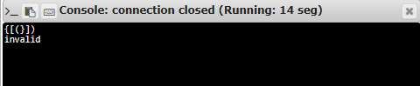

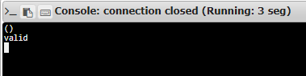

**Result:**

Thus, creating a python program to check if the given brackets are closed with their own respective type and determined if it’s valid or not.

**Link:**

<http://103.53.53.18/mod/vpl/forms/submissionview.php?id=327&userid=1652>